# How to Access SSMS Credentials:

## Once you have downloaded Microsoft® SQL Server® 2017 Express, you will receive the following popup window. Click on Connect Now.

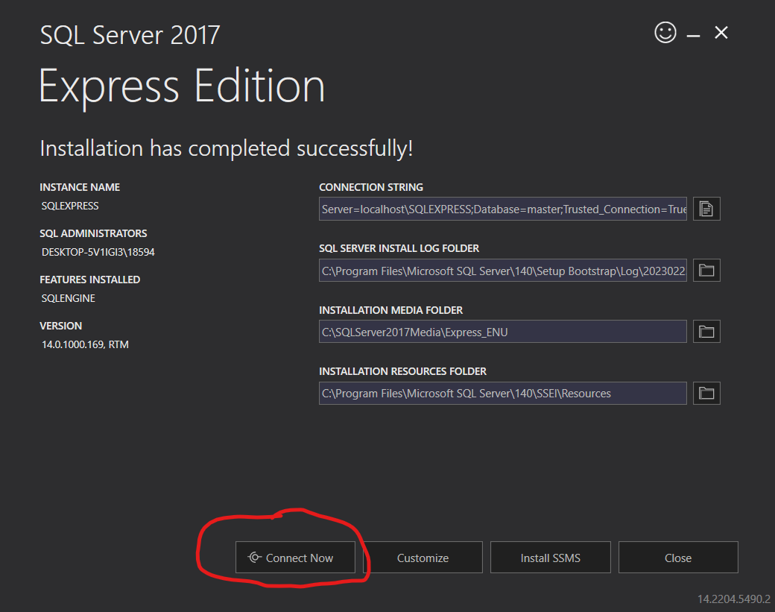

From there, a SQL command prompt window will open up. Your Server Name is in the top left hand corner. Mine is DESKTOP-5V1IGI3\SQLEXPRESS.

Copy and paste into SQL Server Management Studio, and then you’re ready to connect!

